**A Feasibility Study of Surface Penetration Radar for Space Exploration**

1. **Introduction**

Science, targets: Moon, Mars, Europa, Titan, etc.

Focus on Moon and Mars

Surface penetration radar in space applications can be either mounted on a lander or on an orbiting satellite. The former can relatively easily derive fine range resolution with little power. However, the horizontal coverage may be limited by the range of the rover. The latter, on the other hand, can provide a large, often global, coverage. However, because of the high speed of the orbiting satellite, the horizontal resolutions are limited. More importantly, because the satellite has to be at a significant altitude, several facts have to be considered. First, the returned signal power is reduced roughly proportional to the fourth power of the altitude from the surface. Therefore, the penetration radar has to be either very powerful or very sensitive. Second, the altitude becomes an essential factor in determining the transmission time, which determining the range resolution and/or horizontal resolution, and/or cadence time. Third, because the reflection of the surface is extremely strong, the surface structures away from the nadir could produce so-called clutters that can confuse or inundate the weak subsurface signals. Clutter reduction is one of the most important issues for a successful space subsurface penetration radar application. in this study, we focus on GPR on an orbiting satellite.

Existing systems: SHARAD, MARSIS, SELENE, + ??, Juno

Science requirements depending on objectives. Two major completing parameters are range resolution and penetration depth. Of course, one would prefer a deep penetration with a fine range resolution. In principle, a fine range resolution requires a broader bandwidth which in general is equivalent to higher operation frequencies. On the other hand, a deeper penetration requires a lower operation frequency. Any science project needs to balance these two competing requirements. In this study we focus explore the possibility to achieve both.

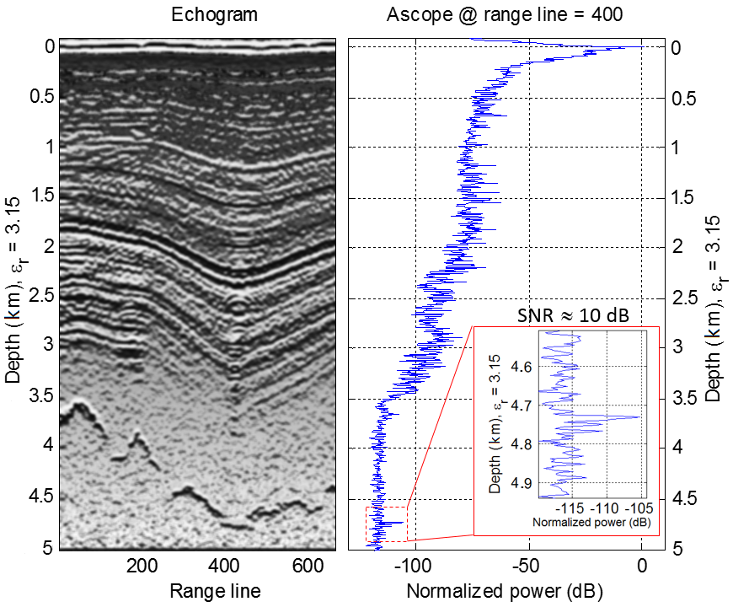

**Figure 1.** Example of surface penetration radar result in Greenland ice [Gogineni 2013]. The Radar was at on an airplane flying at 50 m altitude. The surface is water ice. The echo from the rockbed was detected 4.75 km below ice surface, 10 dB above the background noise level.

Ground penetration radar is different from conventional detection radar because its aim is the properties and characteristics beneath the surface instead of the distance and surface features which are the focus of the conventional detection radar. As expected, the strongest signals are the reflection from the surface. The signal penetrating through the surface is weakened and continuously attenuates because of the absorption and scattering processes in the medium, properties of which are of interest. There are two main processes that produce the signals to be observed by the radar: reflection and backward scattering. Reflection occurs at the interface between two different media when the thickness of the interface is much less than the wavelength and when the size of the reflecting surface normal to the incidence is much greater than the wavelength. Scattering, in an idealized situation, occurs within an overall more-or-less homogeneous medium in which non-uniformities and voids of sizes less than the wavelength are relatively evenly distributed throughout the medium such as a mixture of rocks of sizes less than wavelength or rocks with sand. Reflection can be considered unidirectional and, when the reflecting surface is nearly normal to the incidence, the signals are able to be received by the radar. On the other hand, scattering produces signals that are more isotropic in all directions. Only can signals within a small stereradian be detected by the radar if the radar is on an orbiting satellite.

In reality, subsurface media can form various structures and combinations. For example, natural ice sheet is formed from accumulation of snow over years. Due to seasonal, annual, and climate variations, sublayers can form, see Fig 1. Furthermore, the surface and subsurface may have nonplanar structures of sizes greater than the wavelength. These structures produce spottier signals of strength similar to reflection at interface. In a single measurement, right panel of Fig 1, one is not able to determine whether the fluctuations are from a single interface or from a large boulder (on or below the surface) or a mountain structure. Because the reflection points from these structures, which may have irregular shapes and orientations, change when the radar moves or when the radar beam changes its direction, these moving reflecting points can be recognized and suppressed in the synthesis aperture radar (SAR) processing. (Prasad, there is a problem here, the layers shown in Fig 1 are mostly not normal to the radar, how can reflection reach radar?) The discussion in section 2 is based on physical understanding of this case.

1. **General Consideration** 
   1. **Received Radar Signal Strength.**

The following estimate is based on a multi-layered locally planar subsurface structure of a planetary body. Reflection occurs at the interface between two neighboring layers. Within each layer, the signal is attenuated at a rate of α. From the radar equation, the signal strength received by a penetration radar for a planar interface target is

 (1)

where *P*T, *G*T, *G*r, *L*r, *G*p, λ, *z*, and *z*j are the transmission power, transmitter gain, receiver gain, fraction of the transmitted power in the receiving band, processing gain, wavelength, penetration depth, and the depth of interface *j*, respectively. Radial distance, or range, *R* is

 (2)

where *r* is altitude of the radar from surface,  is the thickness of layer *i*, and *n*i the index of the refraction of medium *i*. Factor η is the fraction of the backward scatter with a small steradian that can reach the receiving antenna and  is coefficient of scattering.

Quantity  is the reflectivity at interface between medium *i* and medium *i*+1 and is nonzero only at the interface of interest as indicated by the δ-function. The transitivity is  and the square of it accounts for the 2-way propagation. The factorial is from the surface, *j*=0, to interface *j* which is at or just above the point of interest. Since there are a few typical interfaces that are of interest to space explorations, we list them in Table 1.

Table 1. Reflectivity and transitivity of typical interfaces for space explorations

|  |  |  |  |  |
| --- | --- | --- | --- | --- |
|  | Vacuum (*n*=1) | Water (*n*=1.33) | Ice (*n*=1.31) | Rock (*n*=2.65) |
| Vacuum | Γ=0  (1−Γ)2=1 | Γ=0.020 (-17dB)  (1−Γ)2≈1 | Γ=0.018 (-17dB)  (1−Γ)2≈1 | Γ=0.204 (-6.9 dB)  (1−Γ)2=0.64 (-2dB) |
| Water | Γ=0.020 (-17dB)  (1−Γ)2≈1 | Γ=2.5x10-5 (-46dB)  (1−Γ)2≈1 | Γ=5.7x10-5 (-42dB)  (1−Γ)2≈1 | Γ=0.11 (-9.6dB)  (1−Γ)2=0.79 (-1 dB) |
| Ice | Γ=0.018 (-17dB)  (1−Γ)2≈1 | Γ=5.7x10-5 (-42dB)  (1−Γ)2≈1 | Γ=2.5x10-5 (-46dB)  (1−Γ)2≈1 | Γ=0.11 (-9.4dB)  (1−Γ)2=0.79 (-1 dB) |
| Rock | Γ=0.204 (-6.9dB)  (1−Γ)2=0.64 (-2dB) | Γ=0.11 (-9.6dB)  (1−Γ)2=0.79 (-1 dB) | Γ=0.11 (-9.4dB)  (1−Γ)2=0.79 (-1 dB) | Γ=2.5x10-5 (-46dB)  (1−Γ)2≈1 |
|  |  |  |  |  |

Here we have assumed that the interface between sublayers of the same medium has 1% of variation in the index of refraction. One important feature in this estimate is that the reflection at the boundary between sublayers of the same medium can be significant, compared with the backward scattering, but in general, no appreciable effect on the transitivity.

It is worth mentioning that the factor of the last brackets in equation (1) is the backward signal produced by reflection and scattering. Within a layer/medium *i*, the reflectivity is zero and only the backward scattering contributes to the received signals. We have assumed that the reflection is produced in a small length in height and approximated it with a δ-function although in reality the reflection enhancement may extend to a longer time interval. The second term in the brackets is not included in many conventional radar equations which track only the reflection. Only does a small fraction of the downward flux is scattered upward. The fraction of the scatter that reaches the antenna is

 (3)

where *A*r is the aperture of the receiving antenna. Because  is often much greater than , mostly because η is extremely small for a space radar, the reflection appears to be spikes as shown in Fig 1, right panel, at surface, *z*=0 km and at the bottom of the ice *z*=4.75 km. The amplitude of the peak above the background scatter is of the order of .

In the case shown in Fig 1, the top surface is an air-ice interface. The surface peak is of the order of 50 dB. The 2-way attenuation rate can be estimated from 3.5 km (−115 dB) to 0.2 km (−50 dB), or −65/3.3=−20 dB/km=−0.02 dB/m. The corresponding one-way attenuation rate is −0.01 dB/m. The wavelength of 300 MHz wave is ~1 m so that the attenuation is −0.01 dB. Because the ice surface changes the index of refraction from 1 to 1.31, the reflectivity is 0.02~−17dB, see also Table 1. Assuming the attenuation is dominated by scattering, and η~−60dB, the ratio is 43 dB. This estimate is in the range of the observed 50 dB peak above the background scattered signal. When comparing the −60 dB due to scattering, the ice-ice reflectivity of −46 dB based on 1% change in index of refraction in Table 1 indicates a 14 dB fluctuation associated with the sublayers within the ice. This is consistent with the fluctuations from 0.2 km to 3.5 km that are in a range of 10 dB. Therefore, the process that produces the fluctuations is more likely due to reflection and not due to changes in the scattering because the latter is unlikely to produce such large amplitude fluctuations.

The last factor in equation (1) is often referred to as loss factor where  is the total signal attenuation rate which consists of effects from the imaginary part of the coefficient of refraction, , conductivity, , and scattering, . In most discussion below we assume that the scattering effect dominates.

* 1. **Noise Level and Signal-to-Noise Ratio.**

The fact that the measured power becomes nearly constant below 3.5 km in Fig 1 most likely indicates the noise level of the system. The noise power, *N*r, is

 (4)

The first term is the thermal noise of the radar and the environment, where *B*r, *k,* *T*, and *E* are the bandwidth of the receiver, Boltzmann constant, temperature, and the noise figure, respectively. It is due to effects such as thermal noise level of the electronic system of the radar and the background thermal emission. The second term, *N*rad, is the contributions from radar signal itself such as the sidebands of the frequency spacing, or repetition rate, and period of each scan [e.g., Gogineni et al., 2014], and the third term, *N*other, is associated with other sources which can be more important in space and will be discussed further in section 2.3.

Conventionally the detectability is determined by the signal-to-noise ratio, (1) divided by (4),

 (5)

When the noise level is higher than the signal level, or signal-to-noise ratio *SNR*<1, according to conventional wisdom, the limit of penetration is set at *SNR*>3 when a radar is not able to provide information of the medium from the noise.

However, very often space exploration may be more interested in the existence and the depth of an interfacing boundary, such as the bottom of ice sheet in the case of the Europa, the thickness of the ice sheet in the case of Moon or Mars, and ceiling and floor of a cave in the case of Moon, instead of the fine subsurface sublayers. The case in Fig 1 has demonstrated clearly that although noise dominates the measurement below 3.5 km, a boundary at 4.7 km can still be detected. Therefore, detectability of a boundary can be extended to a few tens dB below zero of the *SNR* that is determined by the *scattering* effect compared with noise and/or small fluctuation in the index of refraction between sublayers.

In the case of Fig 1 if we assume that the scattered power continues to decrease exponentially, at a similar attenuation rate, at 4.75 km, the signal attenuation from 3.5 km is −1250x0.02=−25 dB below the noise level. However, this is only for the backward scattered signal, the second term in the last brackets of equation (1). When the transmitted signal encounters the bottom interface, the first term takes over and generates a strong reflected signal that can be observed unambiguously. The reflectivity at the ice-rock interface, from Table 1, is −9.4 dB. When compared with the −60 dB due to scattering, the reflection is then −9.4+60=51 dB above the backward scattering. The predicted peak could be 51−25=26 dB above the noise level. The observed peak is about 12 dB above the noise level. There are many possible reasons for this quantitative mismatch. For example, if the rock bed is wet, as many expected, the reflectivity for ice-wet rock can be much smaller, between the reflectivity for ice-rock (−9.9 dB) and ice-water (−42 dB). Or, the attenuation rate may increase below 3.5 km as the indication for such increase near 3.5 km as seen in Fig 1. In this possibility, the scattered signal is more than 25 dB below the noise level. We note that in the above estimate the effect of the η dependence on depth has been included in the attenuation rate estimate.

* 1. **Constraints and Strategy for Space Surface Penetration Radar.**

The instrumental requirements for a space radar system is driven by the scientific objectives of the mission as discussed in the Introduction. In general, range resolution, penetration depth, and horizontal resolution are the three leading science controlling factors constrained by technical controlling factors of power and data volume. The mass, volume, and deployment mechanisms are secondary factors although they may play critical roles in the final selection. We will include these secondary factors in the discussion. However, our focus is the new capabilities that the next generation of surface penetration radar can bring on a space platform.

***Range resolution.*** The range resolution of a pulsed radar is given by ∆*R* = *c*/2∆*f* for free-space ranging, where *c* is speed of light in free space, and ∆*Z*i = *c*/2*n*i∆*f* for medium ranging, where ∆*f* is the bandwidth of the signal [e.g., Skolnik 1962]. In the following discussion, we convert the range to that in free-space. It is obvious that for a fine range resolution, a large bandwidth is needed and there is no alternative. As the wideband and narrowband designation refers to the bandwidth compared with the center frequency, for a given required range resolution, a system has to be a wideband if using lower center frequency or it can be narrowband if using a very high center frequency. For example, if the desired range resolution is sub-meter, we may choose a bandwidth of ∆*f* =300 MHz, which leads to a range resolution of 0.5 m in vacuum.The large bandwidth can be easily achieved at a narrowband system at a higher operation frequency, e.g. 1 GHz. This high frequency will lead to a small penetration depth and a large data volume as to be discussed in the next subsection. We will discuss the strategies that use narrowband low frequency transmissions. The alternative is a broadband. However, the broadband has its own problem.

For a space system design, there are two major effects that need to be considered. The first is the noise spectrum of the operating environment. In space radar, any emissions not from the radar itself is considered noise or interference although it may be useful for other purposes, for example from radio communication, navigation and broadcast signals, radio emissions from the sun and radiation belts, and space plasma waves. The noise in the last term in (4) can be much greater than the thermal noise. A careful examination of the spectrum of radio emissions in the radar orbit is necessary. A strong source of narrowband interference can be fatal to a simple broadband system if it within the bandwidth. On the other hand, a stepped-narrowband system may be able to skip some frequencies of strong emission. It is possible to build an intelligent system that first scans the background radiation spectrum and then operates in relatively low-noise frequency bands.

The second effect is the fading effect. In space, when radio waves propagate or penetrate in to a medium, because of dispersion and damping, some frequencies may attenuate faster than others. If this occurs in one end of the bandwidth, the effective bandwidth is reduced so that the range resolution is lowered.

***Penetration depth.*** For space explorations, it is often desirable to have a deeper penetration. From equation (1), the controlling factor is the signal attenuation rate, the last factor. However, very often the attenuation rate is poorly known and may actually be part of the science objective—to learn about the composition and structure of the medium. For example, the attenuation rates may range over as large as a factor of 20 between experiments on lunar samples [Gold et al. 1970] and GPR observations over Earth analogs [Heggy et al. 2006]. Therefore, the predicted penetration depth of a lunar penetration radar can differ by a factor 20 which is sufficiently large to rule out the feasibility of a system. In other words, it may evaluate the feasibility of a system in terms of the available dynamic range *SNR* for penetration.

In principle, a lower operation frequency or longer wavelength may penetrate deeper according to equation (1). However, a lower frequency in general requires a larger antenna system which increases the mass, volume, and, likely, the cost of the system.

***Horizontal Resolution.*** The radar emission illuminates an area on the surface called Fresnel zone. Its diameter is

 (6)

The returned signals are assumed to be an average of the backward radiation from the Fresnel zone and, in theory, one could not resolve features within the Fresnel zone. It is obvious that a lower orbit and/or a higher frequency leads to a higher horizontal solution. Unfortunately, most often the satellite altitude is very large, resulting in a very large Fresnel zone. The horizontal resolution along the satellite track can be improved if the radar measurement is fast enough and/or the satellite moves slow enough when multiple complete measurements can be made within a Fresnel zone. With the information from the multiple measurements within a single Fresnel zone, the Synthesis Aperture Radar (SAR) processing method can improve the horizontal resolution along the satellite track. Similarly, the radar beam can be steered across the track so that multiple complete measurements can be made in the cross-track direction and used to improve the cross-track resolution.

When designing a space system, the above three requirements have to compromise. In general, the horizontal resolution is a lesser concern because most space missions often concern properties of global scales.

* 1. **System Design Strategy.**

***Computer Centralized Control.*** Our objective is to develop a system that can achieve multiple scientific goals, e.g. fine range resolution, deep penetration, and sufficient horizontal resolutions. However, because the properties of the target are often poorly known, we may encounter many unanticipated situations. On the other hand, an advantage of a space platform is that the satellite may revisit the same area repeatedly. We do not need to do it right for the first time and we have opportunities to make adjustments, if we are able, to improve the result. This would require the system to have capability of in-flight modification. It is obvious that the system has to have a computer centralized control system that can modify the operation. In such a system, hardware needs to be flexible and able to change, for example, its frequency, waveform, and operation time sequence. Thanks to the cell phone technology development and many advancements in radio technologies, digital radio transceivers with such capability are widely available. A computer that controls the hardware can take commends from ground or make adjustments self-adaptively. Such a control system has been developed and successfully operated in space. Therefore, on the system level, we can design a system based on computer centralized control that will produce the frequency, bandwidth, waveform, and time sequence as the radar source and coordinate with the receivers to select only desirable signals. It can operate as many transceivers as possible with beam steering function under the general constraint of power, data volume, physical size, mass, and total cost. In the following we discuss some key issues as well as possible solutions in system design.

***Ultra Wide Band Radar.*** A possible solution to the apparent conflict between the range resolution, which prefers higher frequencies, and the penetration depth, which prefers lower frequencies, may be an Ultra-wideband (UWB) system that operates at a lowest possible center frequency but with a widest possible bandwidth. For example, for a submeter range resolution, Δ*f*=300 MHz, one can set the operation frequency range from 100 MHz to 400 MHz with a center frequency of 250 MHz. This frequency range can shift down with a longer and larger antenna system if desirable. We will later use this frequency band to illustrate a system in section 3.

***Power.*** For a space system, the satellite altitude is often much greater than the penetration depth so that *R~r.* As shown in Table 1, the transitivity effect is unimportant. The signal-noise ratio becomes, if assuming *L*r=1 and *G*T =*G*R,

 (7)

In space, the transmission power is limited by the power available on the satellite. The efficiency of the transmitter, especially its power amplifier, becomes one of the key issues for higher power radar. The consumed power by the transmitter becomes heat and has to be ducted away, a significant task in system design. Without an efficient power amplifier, to increase the transmission power is not an effective approach to raising *SNR* unless there is no other choice. For example, from 100W to 500 W *SNR* increases only 7 dB.

***Processing Gain***. How to increase the antenna gains will be discussed later in this section.

There two major methods to increase the processing gain: pulse compression and SAR processing, or  .

Pulse compression gain is

 (8)

where κ is a factor that accounts for the transmit waveform shaping to reduce Fresnel ripples and weighted to reduce to side lobes, normally κ~0.5. *T*u and *T*c are uncompressed and compressed pulse length, respectively. The compressed pulse length is typically *T*c=16/*f*. There is an upper limit for uncompressed pulse length that is 2-way travel time of signal from the radar to the surface, or *T*u =2*r*/*c*, for a long pulse. The upper limit of the compression gain is 38 dB. This upper limit may be considered for the deeper penetration scheme as to be discussed later.

The SAR processing is usually down on the ground. It equals the number of complete measurements when the satellite travels through a Fresnel zone. If we assume the time to make a complete measurement equals 2-way signal travel time, it is

 (9)

On a 50 km altitude orbit for 1 m wavelength and the satellite traveling at 1.5 km/s, the SAR processing gain is 28 dB (36db?).

These two processing gains, a total of up to 66 dB, are essential to the success of a system because other effects are more or less determined or constrained or less flexible.

***Sounding Schemes.*** Radar measures the time delay and amplitude. The latter is described by equation (1), of a returned signal. The time delay is used to determine the distance of a returned signal. A shorter signal pulse, corresponding to a wider frequency band in Fourier space, would give a more accurate timing of the delay. A longer pulse, corresponding to a narrower but stronger peak and deeper penetration, will result in poor timing because the received signal at a given time is the summation of returns of different times in the source signal but from different depths. It is clear that even if compromise can be made, the fine range resolution and deeper penetration are fundamentally contradicting each other. There are three major sounding schemes or waveforms under consideration: the UWB chirp, stepped-chirp, and narrowband long pulse.

Chirp signals are widely used in ground penetration radar. In the UWB scheme, each pulse is comprised of a bandwidth of signals. The pulse can repeat in time to increase the strength of the signal. In the stepped-chirp schedule, each chirp pulse has a narrower frequency bandwidth and then step through the whole frequency range in time. If the pulse length for the two schemes can be the same, one has a wider band with a number of same pulses and the other with a narrower band with the same number of pulses going through the frequency range in time. The latter has weaker signal strength, because of short duration at a frequency, but the narrowband receiver also results in a lower noise level. In theory the two schemes would obtain the same range resolution and penetration depth if the noise has not spectral features, i.e. white noise although the UWB scheme results in a greater data volume. However, if the noise is white, the higher noise level will affect every pulse in the UWB scheme but only a limited number of frequencies. Even better, the stepped-chirp scheme can modify the bandwidth to avoid the interfering frequencies.

The narrowband long pulse scheme was mostly used in environments with strong interference. A long pulse is compressed to obtain compression gain. The ambiguity in the timing appears no problem because the timing can be relative to the surface reflection. Furthermore, if the interest concerns only the depth of the interfaces, such as the ceiling and floor of a cave or an ice volume, the depth detection can substantially increase. It is also possible to use two adjacent frequencies to improve the range resolution.

A system needs to be flexible and able to conduct all three sounding schemes in order to best utilize the investment for any unforeseen situations.

* 1. **New Technologies Available**

***Multiple-input and Multiple-output Radar.*** Multiple Input and Multiple Output (MIMO) radar has become a topic of significant research for automotive applications over the last few years. For a radar with M-transmit antennas and N-receive antennas, traditional processing takes information from these M+N phase centers. In principle, if taking the radar target as a linear system, at a given frequency, the M outputs and N inputs of the radar, the target may be described by a MxN matrix. Each element is referred to as a phase center. Note that the matrix is symmetric according to reciprocal law, i.e. only half of the off-diagonal elements carry useful information. These MxN parameters that can be determined from data between each possible pair of transmitter and receiver. This is MxN pieces of information about the target, more than M+N when M and N greater than 2. Fully exploiting the information in the matrix, a MIMO radar is able to provide more robust and finer angular resolution than a typical phased-array radar. Although the concept of a MIMO radar is not new, its potential for civilian applications is only being realized now because of the advances in digital and RF technologies [Bliss and Forsythe 2003; Bergin and Guerci 2018] as a result of large investments made by communications and automotive industries.

**Figure 2.** Radar echogram of data over the onset area of the Slessor glacier in Antarctic with UWB microwave radar. The white spaces are buried crevasses.

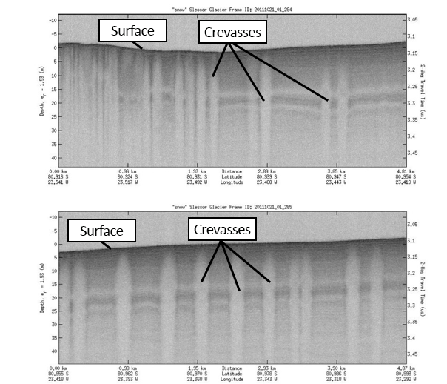

A MIMO, coupled with ultra-wide bandwidth, has potential to transform sub-surface sounding, offering unprecedented range and horizontal resolutions. Figure 2 shows the results from an UWB microwave radar (2–8 GHz), with ~10-cm range resolution, being flown as a part of the NASA Operation IceBridge (OIB) mission to detect snow buried crevasses (seen as vertical light-grey colored structures) [Gogineni et al. 2015]. The fine resolution and ability to penetrate snow made it possible to clearly map buried crevasses near an outlet glacier. The range resolution is ~10 cm with horizontal resolution of meters on ice. This system operates at 2–8 GHz.With the increasing capability of on-board and on-ground processing digital RF technologies, multiple-frequency narrowband transceivers can be made economically so that a large bandwidth can be realized in space. Comparing this system with the one shown in Fig 1., it is clear that a finer resolution provided by this high frequency system is at the cost of deeper penetration consistent with the discussion in section 2.3.

***Tightly-Coupled Dipole Array.*** Traditional dipole and reflector antennas are widely used in space missions due to their simplicity and lower cost [Imbriale, 2006; Pisacane, 2005]. But they suffer from poor directionality and feed-blockage which result in lower radiation efficiency and relatively narrowband of radiation. For ground penetrating radars, as discussed in section 2.5, in order to obtain high range resolution, wideband radars are more desirable. To improve the horizontal resolution, capability of scanning in the direction across the track is also desirable. Since in space any physical movement by an instrument in operation is strongly discouraged as it may change the satellite’s attitude and produce much noise. Therefore, the scanning capability has to be achieved by beam steering. The TCDA technology perfectly fits to provide these functionalities: UWB and beam steering. In addition, TCDA, Fig. 3, is low profile, more compact and lighter weight, providing orders of magnitude reduction in size, weight, and power (SWaP) for satellite payloads.

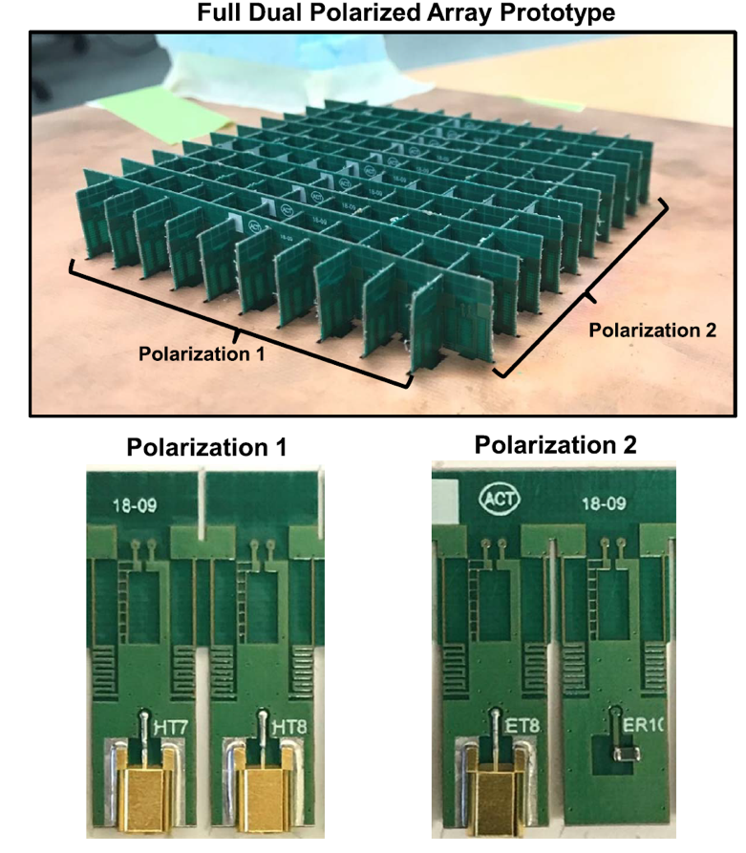

**Figure 3.** An example of TCDA. A unit of transmission and reception array, that comprises a print-circuitry of build-inductance, resistance and capacitance.

In a nutshell, looking from the transmission side, a TCDA consists of a series of L-C-R resonance circuit elements that are built on multiple print circuitry boards (Fig. 3 bottom), which can resonate with many frequencies according to impedance matching. on the receiving side, the cell structure produces reflection of unwanted waves. Several unique features make the TCDA aperture a game-changer for space subsurface explorations They are: (1) scalable frequency range which has been tested from 190MHz up to 95GHz, (2) highly compacted structure in terms of element size and thickness-- the thickness of an antenna panel, or the height of the cells, is as small as λlow/12 and unit cell size of λlow/15, (3) wide and continuous bandwidth of more than fmax:fmin= 10:1 and up to 50:1, (4) ability to accommodation a large number transmitters and receivers, and (5) low cost and ease to deploy with a highly conformal aperture which can be mounted and deployed easily using a solar panel deployment mechanism or with a solar panel structure. Items (3) and (4) naturally match the need for an UWB MIMO system as discussed in the last subsection.

1. **A Strawman System**

**Figure 4.** TCDA array deployment for space application using dual-polarized antenna elements to populate the array. Notably, 4 antenna elements in each polarization are combined together into a single input/output

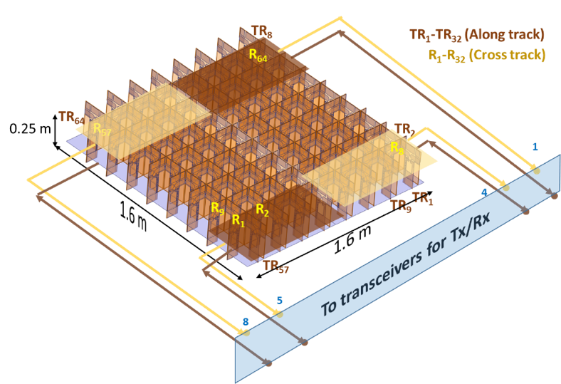

In this section, we demonstrate a strawman system that is potentially deployable for Moon or Mars shallow surface penetration. We choose our target range resolution as 1 meter and penetration depth as 100 meters. We assume the operation frequency range is from 100 MHz to 400 MHz with bandwidth of 300 MHz, or theoretical range resolution of 0.5 meter in free space or 0.2 meter in rock. This should leave enough margin for the desirable 1-meter range resolution.

It provides multiple operation modes and in-flight flexibility. Because the overarching architect of the system is a central computer, it is scalable for different types of targets and operating conditions and operates at different frequency with minimal hardware modifications. In the following discussion we only focus on the space flight part of the system assuming the data can be processed and analyzed on the ground using the conventional methods and technques.

***Antenna.***In this frequency range for a space system, the optimal system size of the TCDA, determined by the lower frequency of 100 MHz, 1.6 m x1.6 m. We assume 8x8 cells so that each cell is 0.2 m x 0.2 m with a height of 0.25 m. This low profile with the total thickness being only λlow/12 and unit cell size= λlow/15, yet providing a total gain of 14 dB at 250 MHz. We drive the array with 8 transmitters and receive with 8 pairs of receivers for two polarizations which are critical to differentiate between ice and regolith. Therefore, there are 8 arrays and each controls 8=2x4 cells as shown in Fig 4. This modest sized antenna system should be able to be accommodated in many planetary missions and even integrated to the back of a solar panel structure as the radar looks down the solar panel may look at the sun.

Numerical simulations of the TCDA system is shown in Fig. 5. The frequency response of an antenna system is measured by VSWR which is the ratio of voltages of maximum standing wave to minimum standing wave. For a well-matched antenna system, VSWR needs to be below 3 dB in the operating frequency range. Our strawman system can well operate from 100 MHz to 650 MHz showing the potential for wider bandwidth, i.e. finer resolution. The gain of the system is 6 dB and 14 dB at 120 MHz and 250 MHz, respectively (Fig. 5). It should be noted that the gain varies linearly with the number of elements closely following the theoretical limit of $G=\frac{4πA}{λ^{2}}$, with A being the effective antenna aperture area. The corresponding 3dB beam width for this antenna will be 40º at the center frequency of 250 MHz in both planes due to its square configuration. The beam can be steered and scan in desirable angles and sequences.

This low profile TCDA with a height of λlow/12 (25 cm thick) results in at least 5 times reduction in thickness profile as compared to other conventional Vivaldi antenna arrays [Zhong et al., 2019].

***Transceiver system.*** Fig 6 shows a strawman block diagram of the electronic system. It takes desirable waveform and time sequence of the sounding signal from the radar control system generated by the computer algorithms which can be modified when needed. The transmitter synthesizes the signal and distribute to the 8 antenna elements with appropriate phases. The antenna receives the returned signals in 16 channels. The receivers digitize and process the data before sending to the satellite data system for downlink. Because of the large amount of on-board processing, calculation as well as control comments, we expect that two set of CPUs and FPGAs are needed to handle the 8 transmitters and 16 receivers.

**Figure 6.** LunarMIMOR block diagram

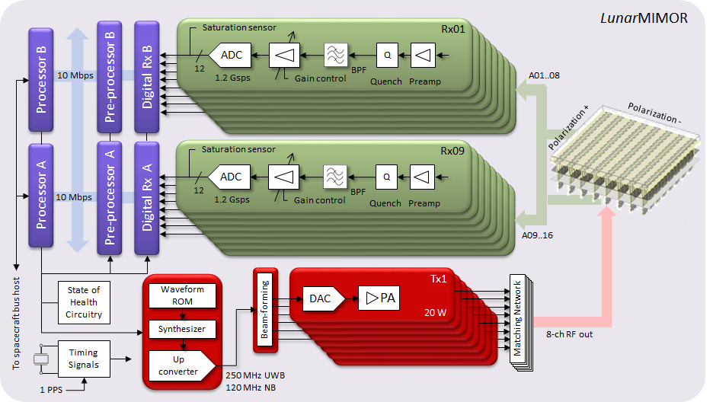

We assume each transmitter transmits 20 W and the total transmission power is 160 W which is reasonable for many satellite systems.

Table 3 summarizes the parameters for this strawman system. Table 4 shows the expected performance. We include a narrowband long pulse mode centered at 120 MHz with 40 MHz bandwidth and a UWB chirp mode center at 250 MHz. In Table 4, we also include the situation for rough surfaces.

**Table 3.** Strawman system specifications

|  |  |  |  |
| --- | --- | --- | --- |
|  | NB Mode | UWB Mode | Units |
| Radar Center frequency | 120 | 250 | MHz |
| Bandwidth | 2@1 | 300 | MHz |
| Peak transmit power per channel (Ant array element) | 20 | 20 | W |
| Total peak power | 160 | 160 | W |
| Transfer Switch and cable losses | 2 | 2 | dB |
| Receiver noise figure | 2 | 2 | dB |
| Transmit antenna gain | 6 | 14 | dB |
| PRF of pulses in a burst | 25 | 25 | kHz |
| Burst PRF | 1500 | 1500 | Hz |
| Receive antenna gain | 6 | 14 | dB |
| A/D converters | 1000 | 1000 | MHz |
| sampling rate | 100 | 800 | MHz |
| # Bits | 12 | 12 | bits |
| # Converters | 16 | 16 | bits |
| Digital chirp generators | 1000 | 1000 | MHz |
| # channels | 8 | 8 |  |
| Sampling rate | 500 | 1000 | MHz |

**Table 4.** Radar System Design and performance for planar and rough interfaces

|  |  |  |  |  |  |  |  |  |  |
| --- | --- | --- | --- | --- | --- | --- | --- | --- | --- |
|  | **Planar Interface** | | | |  | **Rough Interface** | | | |
| Frequency | 120 MHz (NB) | | 250 MHz (UWB) | |  | 120 MHz (NB) | | 250 MHz (UWB) | |
| Transmit Power including cables and switch losses | 50.00 | dBm | 50.00 | dBm |  | 50.00 | dBm | 50.00 | dBm |
| Combined Transmit and receive antenna gain, GT GR | 12.00 | dB | 28.00 | dB |  | 12.00 | dB | 28.00 | dB |
| Wavelength, λ^2 for planar and λ^3 for rough | 7.96 | dBm^2 | 1.58 | dBm^2 |  | 11.94 | dBm^ | 2.38 | dBm^3 |
| Two power transmission coefficient (1-|Γ|^2)^2 | -0.69 | dB | -0.69 | dB |  | -0.69 | dB | -0.69 | dB |
| Pulse compression gain, CI | 38.01 | dB | 31.76 | dB |  | 38.1 | dB | 31.76 | dB |
| Integration gain, M | 36.44 | dB | 34.84 | dB |  | 46.96 | dB | 43.12 | dB |
| Spreading loss term-1 | 28.00 | dB | 28.00 | dB |  | 32.98 | dB | 32.98 | dB |
| Spreading loss term-2 | 94.02 | dBm^2 | 94.02 | dBm^2 |  | 117.52 | dBm^2.5 | 117.52 | dBm^2.5 |
| Noise power, B=300 MHz UWB | -107 | dBm | -85.23 | dBm |  | -107 | dBm | -85.23 | dBm |
| Return loss for planar surface | 20.00 | dB | 20.00 | dB |  | 6.99 | dB | 6.99 | dB |
| The term from area substitution, sqrt (cTc)/vTin |  |  |  |  |  | -34.63 | dB | -35.74 | dB |
| Signal-to-Noise Ratio | 110 | dB | 88.70 | dB |  | 88.06 | dB | 60.54 | dB |
| NB= Narrowband, UWB = Ultra-wideband |  |  |  |  |  |  |  |  |  |

***Sounding modes.*** The system is able to operate at UWB chirp mode, stepped-frequency chirp mode, and narrowband long pulse mode. When encountering something unexpected, such as a curious subsurface feature, special programs can be designed to resolve the issue and uploaded to the satellite. The 16 receivers are tuned, with a proper but adjustable and programmable time delay, to listen to the transmission frequency in two polarizations. With these hardware and flexibility in principle we can make an unaccountable number of possible operation programs or modes. In the following we discuss only two of the often-used modes: the chirp mode and

*Fine range resolution mode.* In this mode we use the chirp mode. It can operate with both long-chirped pulses and step-frequency chirped pulses, obtaining vertical resolution of ≤1 m for detailed survey of regions of interest. In the stepped-frequency chirp mode, we transmit in 16 steps and each step with a bandwidth of 300/16=19 MHz. This mode has been successfully operated for a 600–900 MHz ultra-wideband radar in step-frequency chirped pulse mode [Rodriguez-Morales et al. 2014; Gogineni et al. 2015]. It will have 85 dB SNR for planar surface and 57 dB for rough surface penetration. The depth of the penetration will depend on the attenuation rate. For ice, as shown in Fig. 1, because the 2-way attenuation rate is about 0.02 dB/m, it can penetrate to more than 4 km for planar surface. For rocks, the uncertainty in the 2-way attenuation rate is large ranging from 0.1 dB/m to 2 dB/m. If the 2-way attenuation rate is 0.2 dB/m, the strawman system is able to penetrate 400 m and 285 m for planar and rough surface, respectively. If the rocks are very dissipative with attenuation rate of 2 dB/m, the penetration is reduced to 40 m and 28.5 m respectively for the two types of the surface. This is relatively shallow penetration.

*Deep penetration mode*. In this mode, the objective is to reach deeper although the range resolution may be coarser. As discussed in section 2.2, the strawman system will run the narrowband long pulse mode. It can transmit 2 neighing frequency separated by 30 MHz with 1 MHz bandwidth. The narrow bandwidth reduces the noise taken, by a factor 300, or 25 dB. The two frequencies are transmitted with two long pulses and the net compression gain is increased by 15 dB. This is a total of 40 dB additional SNR for attenuation. For 2 dB/m, this means 20 m deeper. If this is still not deep enough, the bandwidth can be further reduced until the interface is detected.

*Survey mode*. Because of substantially reduced data volume by the narrow-band mode and simplicity in data processing, it can also be used for a large-scale sounding survey to identify sites for more detailed fine resolution surveys, for deeper penetration at locations of interest, or for water ice identification using higher frequencies. It has lower range resolution, smaller data volume, but deeper penetration. This mode is similar to the mature space technologies used in the NASA IMAGE RPI [Reinisch et al. 2000].